Logo%20Main%20200

**Boston University**

**Electrical & Computer Engineering**

**EC464 Senior Design Project**

**Final Prototype Test Plan**

*Canine Tracking with SARTopo*

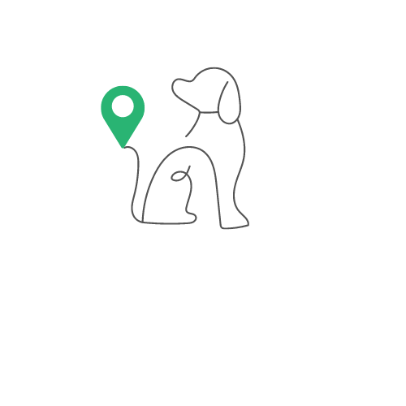

by

Team 17

Team Members

Ragib Ahsan [ragib@bu.edu](mailto:ragib@bu.edu)

Christopher Alonzo [calonzo@bu.edu](mailto:calonzo@bu.edu)

Aanya Kutty [akutty@bu.edu](mailto:akutty@bu.edu)

Ayrton Reulet [reulayrt@bu.edu](mailto:reulayrt@bu.edu)

**Equipment**

Hardware:

* Teensy 4.1
* Sparkfun Max-M10s GPS Module
* Adafruit ADXL345 Accelerometer
* SMA Antenna
* Flora RGB Neopixel V2
* HC-05 Bluetooth Module
* Rechargeable Battery
* 2 7x9cm double-sided PCBs
* 3D printed case
* Android Mobile device

Software:

* Arduino IDE (File already uploaded to Teensy 4.1)
  + Control of accelerometer, LED, GPS Data
* Visual Studio
  + Run Flutter App on the device
* SARTopo Account
  + Saved SARTopo Map
  + Live Locators
    - Call sign
    - Id

**Set up**

To set up our final test, all hardware wiring must be checked to ensure each connection is correct and secure. The PCB board with all the hardware will be placed in the 3D-printed case. We must ensure that the battery is powering the Teensy. A connection must be established between the app and the Bluetooth module to receive and send data. The GPS module must have the ability to connect to a satellite. This may be performed by a window or outside depending on weather conditions.

The YCSR app we created must be installed on the Android device. Additionally, the SARTopo app must be open with a saved map and live locators already in place with unique call signs and IDs. We will demonstrate this for a full understanding of the functionality of our app.

**Measurable Criteria**

| **Criteria** | **Success (Y/N)** |
| --- | --- |
| 1. Battery successfully powers the device | Y |
| 1. LED turns on/off and is controlled by App | Y |
| 1. Connected to the device via Bluetooth | Y |
| 1. Ability to add dog information and save it on the page | Y |
| 1. App displaying “Not Sitting or Sitting” live from accelerometer data | Y |
| 1. Live tracking of the device on a Saved Sartopo Map through our app | Y |
| 1. GPS data successfully converted to .GPX file and saved in phone | Y |
| 1. GPX file uploaded to SARTopo to be analyzed | Y |

**Conclusions**

We were able to demonstrate all our hardware and software features successfully. Most of our feedback revolved around radio transmission. This was a stretch goal, and we were recommended to use a Bluetooth module for ECE day as it will use less power and hopefully give us a longer battery life. From there, most of our discussion surrounded how we would present for ECE day. We are hoping to have two collars that will have the live tracking features, but we need to test if the GPS can connect to a satellite from the 9th floor. If not, we will have the app read previously saved data on a loop to show the functionality. Additionally, we are hoping to make the device as small as possible and attach it to a harness so people could walk around with it. We also want to make our app more user-friendly and have our overall system be more interactive. This includes playing noises when accelerometer data changes, and having better graphics for the “converting to GPX” and “creating Geofences” pages. Finally, we need to ensure that our system works on IOS as all of the testing has been done on Android. From now on, testing needs to happen on the 9th floor, so we will continue debugging and preparing for ECE day there.